

Employer Value
Proposition Worksheet

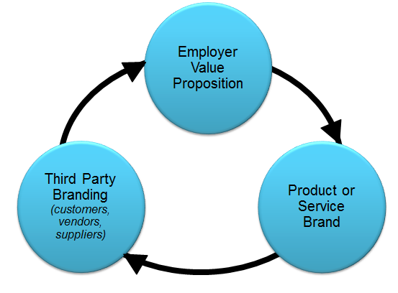


Your Employer Value Proposition
Your Employer Value Proposition (EVP) is a clear, compelling story describing why people work for your organization. A well-defined EVP:

- Engages existing staff members
- Differentiates you for your competitors
- Causes candidates to self-select in or out

Your EVP is essential to the tri-branding of your organization. Tri-branding is defined as the enthusiastic promotion of your organization or product. Experts at tri-branding are companies like Southwest Airlines, BMW, and Apple. Tri-branding is achieved through
:
- Promotion by people in the organization (a clear and compelling EVP)
- Product recognition, quality, and reputation
- Third party promotion (customers, vendors, suppliers)

Employment Brand
(your employer value proposition)

Product or Service Brand
Third Party Branding (customers, vendors, suppliers)

Step 1: Mission (or Purpose)
Definition of Mission or Purpose:
Defines the fundamental purpose of an organization or an enterprise, succinctly describing why it exists and what it does to achieve its vision. For example, a charity might have a mission statement as "providing jobs for the homeless and unemployed".

Examples include:
- 3M: "Our purpose is to solve unsolved problems innovatively
- Merck: "Our purpose is to preserve and improve human life."
- Disney: "Our purpose is to make people happy."

Key Questions to ask:
- Why do we exist as an organization?
- In 100 years, what do we want to be remembered for.
- How are we different than our competitor
- What is the one thing we do as an organization that everyone admires
- What Inspires you for work here?

What is your Mission or Purpose?

Step 2: Define your Vision
Definition of Vision:
Your vision will outline what your organization wants to be, or how it wants the world in which it operates to be (an "idealized" view of the world). It is a long-term view and concentrates on the future. It can be emotive, and is a source of inspiration. For example, a charity working with the poor might have a vision statement which reads "A World without Poverty."
Your vision should be:
Imaginable, Energizing, Feasible, yet Bold, Focused, Flexible, Easy to communicate and remember

“A vision is a picture of the future that captures the imagination of others and
inspires them to follow - Walt Disney

What is your Vision?

Step 3: Define your Values
Definition of Values:
Beliefs that are shared among the stakeholders of an organization. Values drive an organization’s culture and priorities and provide a framework in which decisions are made. Ideally, an organization embraces 3-7 values. Consider values your guiding principles.

Examples of Values:
- Southwest airlines – Fun and value
- P&G – Product excellence
- Nordstrom – Service to customer
What are your Values:

Step 4: Define your Strategy
Define your Strategy:
Strategy – a combination of the ends (goals) for which the firm is striving and the means (policies) by which it is seeking to get there. A strategy is sometimes called a roadmap - which is the path chosen to plow towards the end vision. The most important part of implementing the strategy is ensuring the company is going in the right direction, which is towards the end vision. A strategy is generally unchanged for 3-5 years, with annual goals and objectives.

Summarize your Strategy:

Step 5: Define your Employer Value Proposition
Definition of Employer Value Proposition (EVP):
The EVP is a set of associations and offerings provided by an organization in return for the skills, capabilities and experiences an employee brings to the organization. The EVP is an employee-centered approach that is aligned to business strategies. An EVP must be unique, relevant and compelling if it is to act as a key driver of talent attraction, engagement and retention. Why do people work for your firm?

List the behaviors and traits that define you, that are consistent with your purpose, vision, and values and will help you reach your strategy:

Your Employer Value Proposition
List the top 5 reasons why people work for your firm? Include both What and Why

1
2
3
4
5

List the top 5 reasons people buy your firm’s services or products:

1
2
3
4
5

Identify the overlap that exists in the above 5 lists. The best EVP’s reinforce co-branding between product and employment brand.
Summarize your EVP from the above overlapping areas in a quick, memorable, and captivating way. Test it against using the “Elevator Test” – can you explain to a stranger you meet in an elevator, what you do, why you do it, and why them might want to work for your firm

